09-July Daily Delevirable Packet Tracer
I have built a simple topology in which there is lanA at switch 0 and
And lanB at switch1.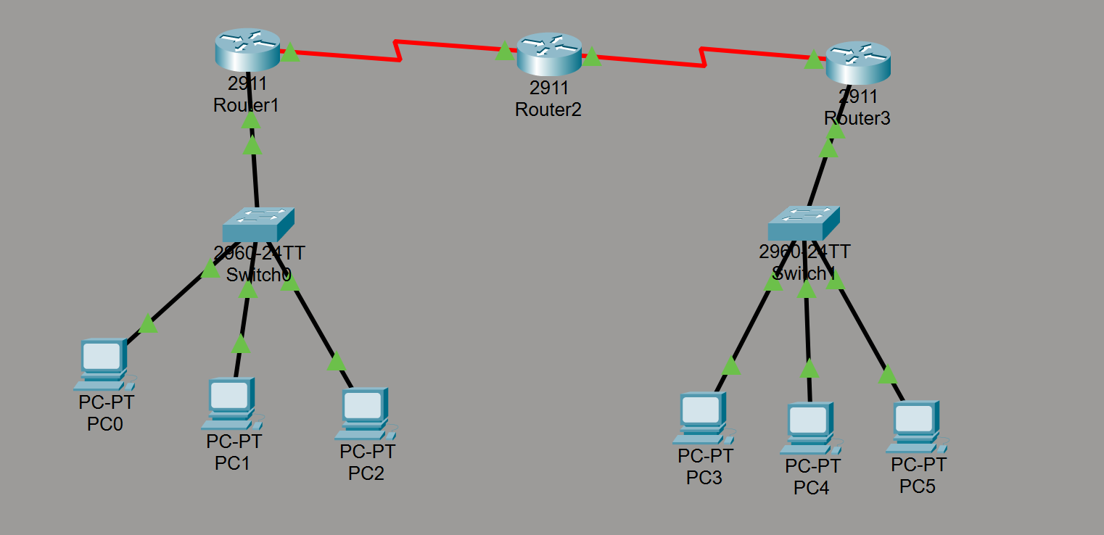
Then I configured the router 1,2,3 interfaces and implemented dhcp and ospf.
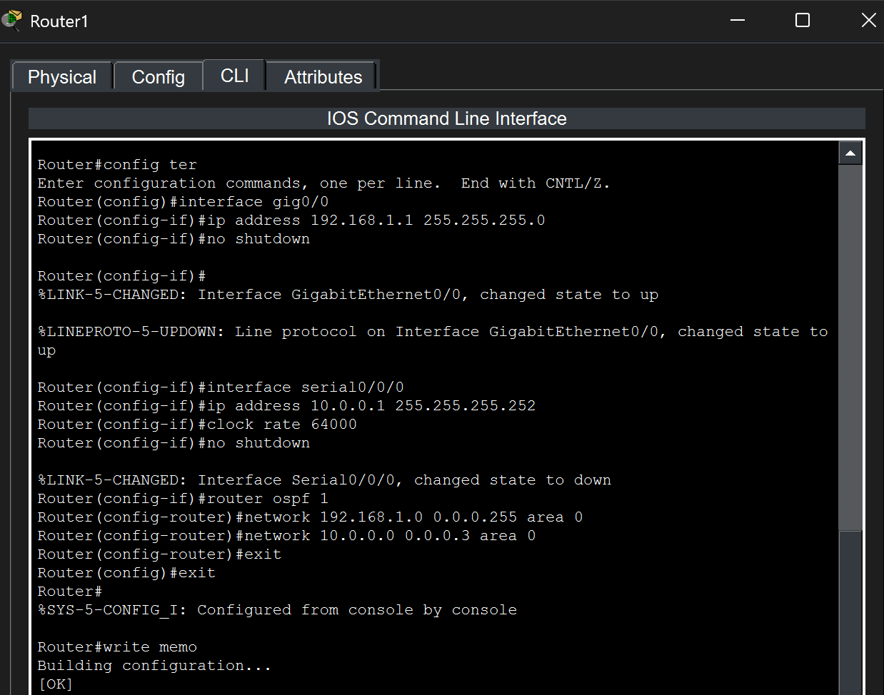

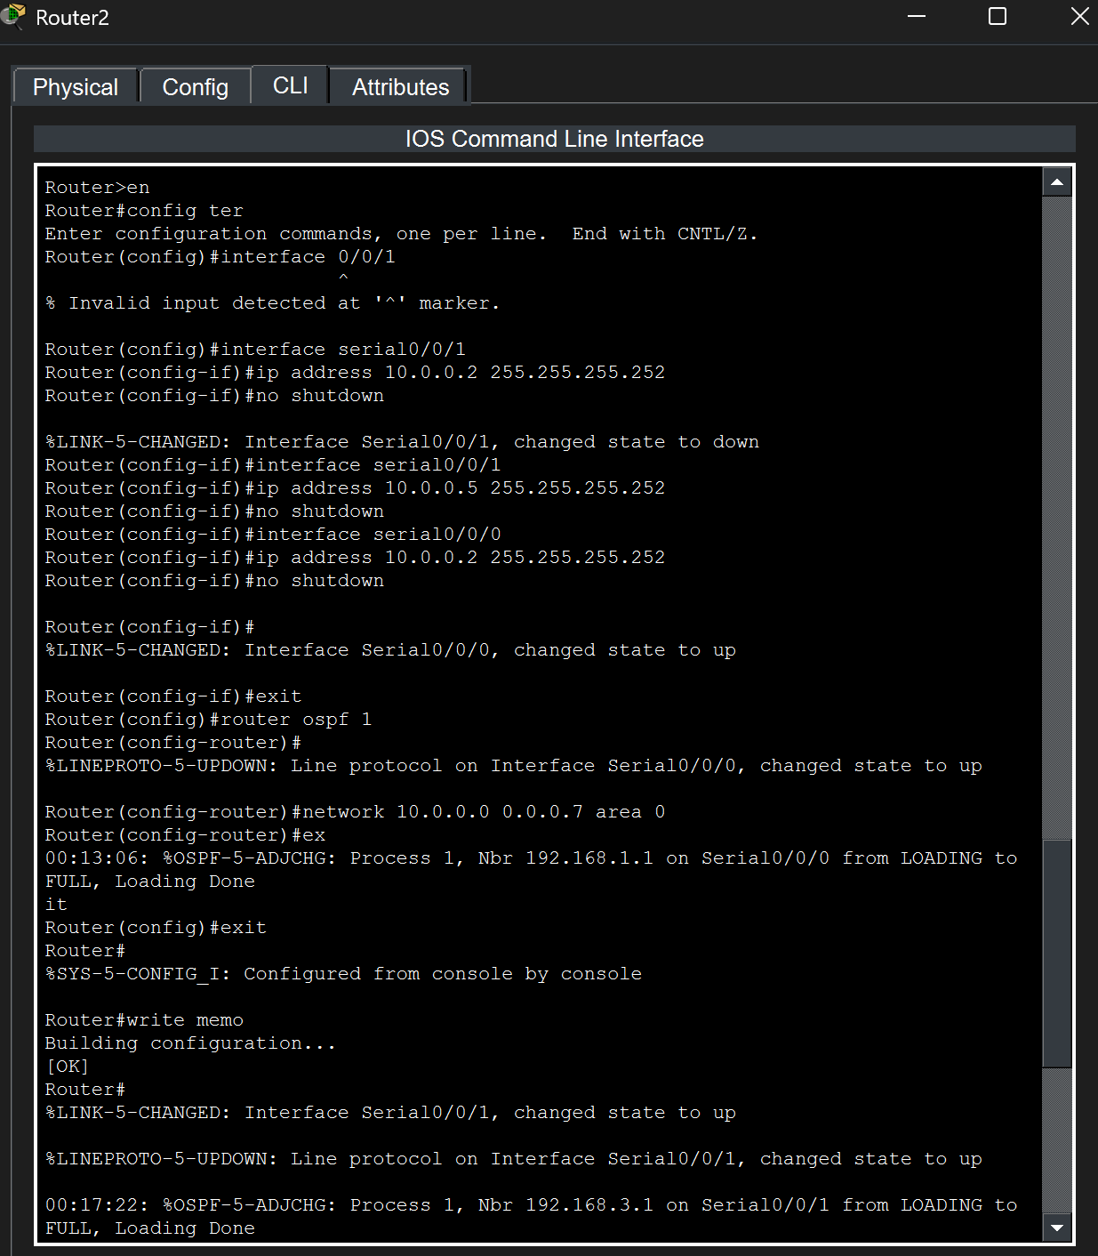
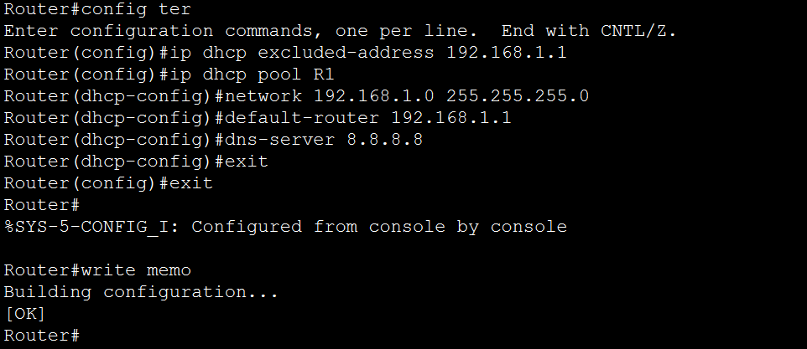

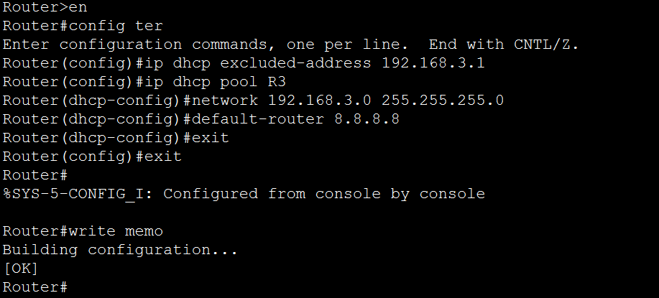
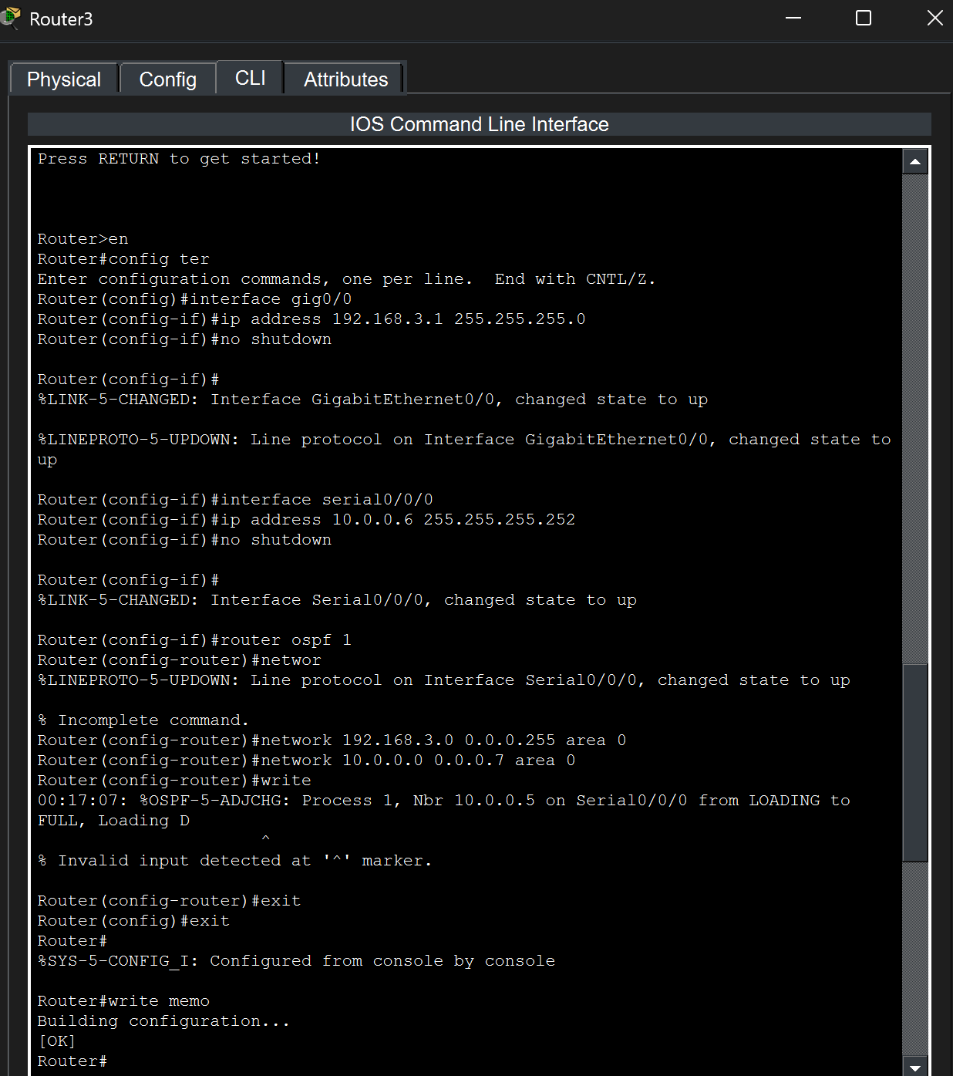

In lanA dhcp assignment to PCs correctly.
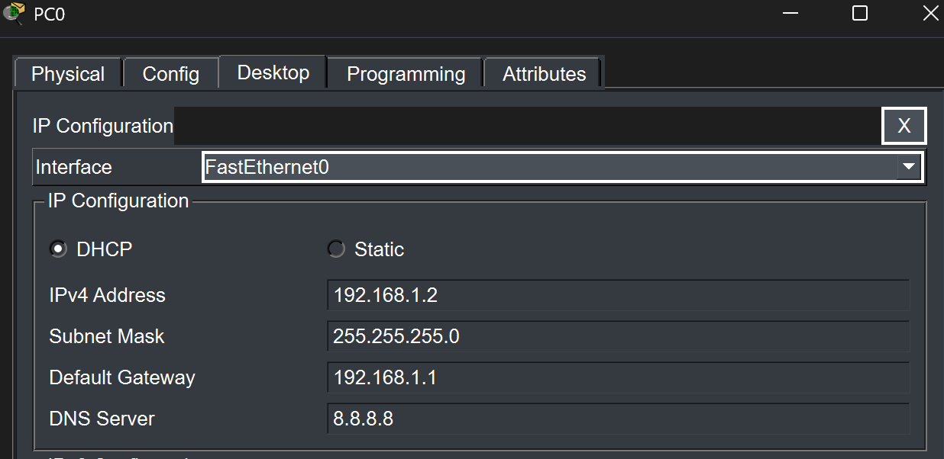
In lanB dhcp assignment to PCs correctly.
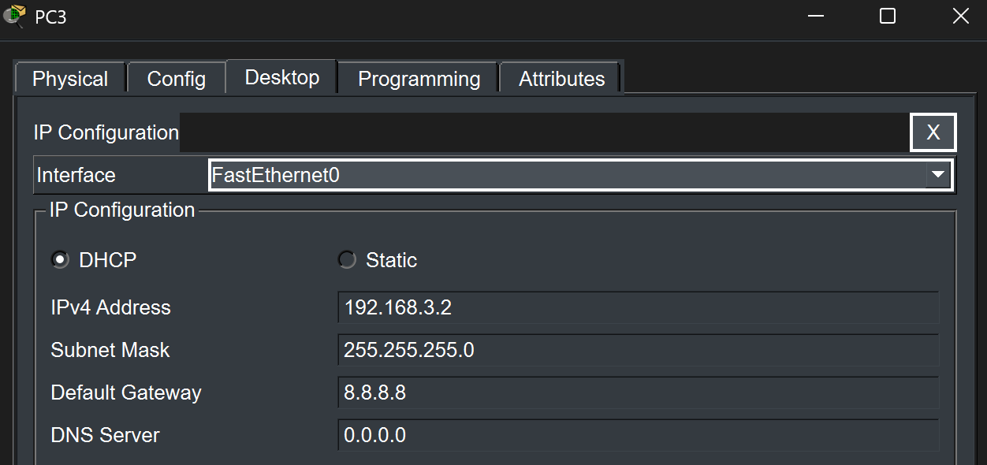

To Confirm OSPF is working and to check the routes.
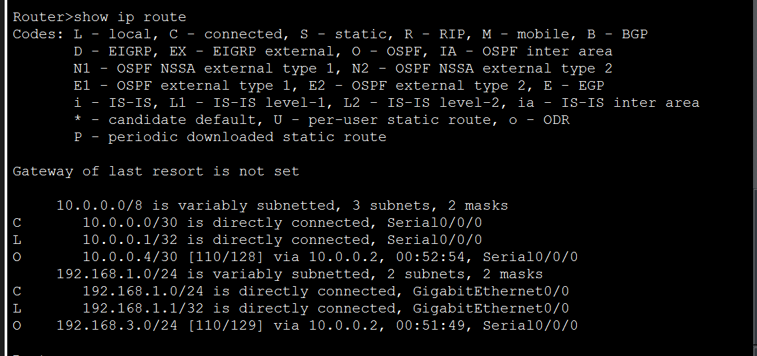
Checking the neighbor routers
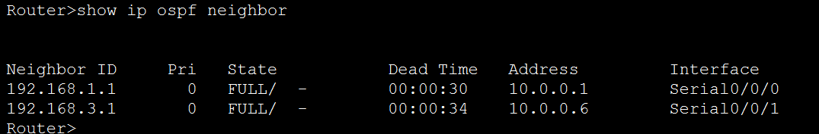
Verify connection between LANs
